FORECASTING LONG-RANGE MONSOON RAINFALL OVER MAINPAT OF CHHATTISGARH INDIA USING DEEP LEARNING
2. Introduction: Identification of internal dynamics of any highly non-linear and chaotic data time series like climatic data is a challenging operational task carried out by the meteorological scientists round the globe. Though in our country, India Meteorological Department is the organization to fulfill such requirements. But their methodology is not enough sufficient to forecast over any smaller geographical region viz. district or division. However Chhattisgarh falls in the range of Central India as divided by IMD. Our study region Mainpat is a block nearby Ambikapur district headquarters. Mainpat is known as the Shimla of Chhattisgarh and it is a very popular tourist attraction place. It is near to Ambikapur in Sarguja district. Mainpat is located at 22.8199°N longitude to 83.2828°E latitude. The average temperature of Mainpat 25°C or 75°F.The rainfall occurs in Mainpat 1383 mm /54.4 inch every year. Since Mainpat is surrounded by planes from 4 or 5 direction the rainfall is above average this area during the rainy season.IMD does not calculate local level forecasting so it is challenging to work forecast data in local levels and deep learning using ANN is the best method to calculate accurate weather forecasting of non-linearity data.
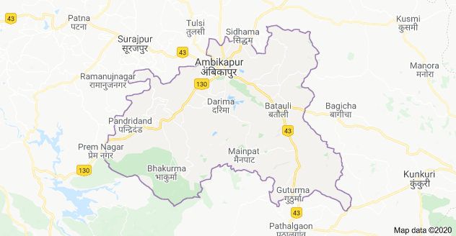
Weather is one of the most imperative and demanding operational responsibilities carried out by meteorological services all over the world. It is a complicated procedure that includes numerous specialized fields of know-how. Amongst all weather happenings, rainfall plays the most imperative role in human life. Human civilization to a great extent depends upon its frequency and amount to various scales. Rainfall is a stochastic process, whose upcoming event depends on some precursors from other parameters such as the sea surface temperature for monthly to seasonal time scales, the surface pressure for weekly to daily time scale and other atmospheric parameters for daily to hourly time scale. The latter atmospheric parameters could be temperature, relative humidity and winds. Variability of weather and climatic factors, especially those atmospheric parameters will be the major force for daily precipitation event.

The World Meteorological Organization acts to standardize the instrumentation, observing practices and timing of these observations worldwide. There are two methods used in weather forecasting. They are the empirical approach and the dynamical approach. The empirical approach is based on analogues forecasting. This method is useful for predicting local scale and forward simulations of the atmosphere. The process is vitalized by computer modeling. The dynamical approach is useful for modeling large scale weather phenomena and may not predict short term weather vagaries efficiently. Most of the weather forecasting systems combine both empirical and dynamical approaches. Neural network involves numerous meteorological applications including weather forecasting.

A Neural Network is a system composed of many simple processing elements operating in parallel whose function is determined by network structure, connection strength and the processing performed at computing elements or nodes. Artificial neural networks (ANN) are parallel computational models, comprising closely interconnected adaptive processing units. The important characteristic of neural networks is their adaptive nature, where ‘learning by example replaces programming’. This feature makes the ANN techniques very appealing in application domains for solving highly nonlinear phenomena. During last four decades various complex problems like weather prediction, stock market prediction etc has been proved to be areas with ample scope of application of this sophisticated mathematical tool. Weather forecasting is found to be more powerful than any traditional system in the classification of meteorological pattern. Numerical weather prediction models, Self Organizing Feature Map, Spatiotemporal Neural Network, and Quantum Neural Network are used for weather forecasting. Neural network can approximate any smooth, measurable function between input and output vectors by selecting a suitable set of connecting weight and transfer functions. Despiteso much of emphasis given to the application of ANN in prediction of different weather events all over the world.

4. Objectives:
The study aims at achieving the following objectives:
- In depth study of Neural Network for Deep learning and identification of internal dynamics of highly non-linear dynamic system like weather data time series.
- To recognize correlated ocean/earth surface predictors i.e. meteorological parameters those are physically connected with long-range SW monsoon rainfall over Mainpat, Ambikapur region geographically located at 22.8199° N, 83.2828° E.
- Optimization of ANN parameters and its architecture before training the network.
- Development of a NN model for Long-range monsoon rainfall forecasting over Mainpat, nearby Ambikapur region of Chhattisgarh.
5. Proposed methodology:
1. Data collection and Preprocessing: Collection of meteorological data set for Mainpat, Ambikapur region and its preprocessing.
2. Optimization of NN architecture.
3. Identification of local meteorological parameters i.e. predictors for long-range precipitation forecasting.
4. Development of a Model for long-range monsoon rainfall forecasting.
6. Expected outcome of the proposed work:
The Model may help us in forecasting long-range precipitation approximately before one month of monsoon season over Mainpat-Ambikapur region.

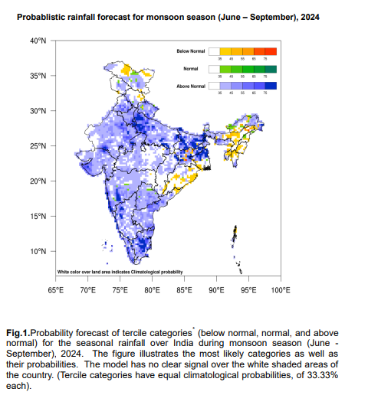
Reference:- PRESS RELEASE (imd.gov.in)

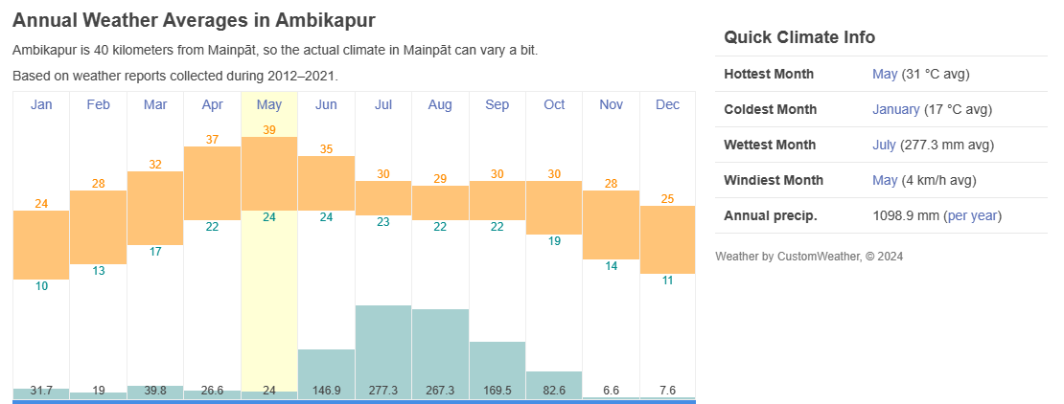
Reference:- Climate & Weather Averages in Mainpāt, Chhattisgarh, India (timeanddate.com)

